Part C Q2. Implement IPv6 Static Routing
Problem Statement
Configure IPv6 static routes on multiple routers to enable communication between different IPv6 networks. Use link-local addresses for next-hop identification. Verify that devices in different networks can communicate with each other successfully.
OUTPUT:
Layout:
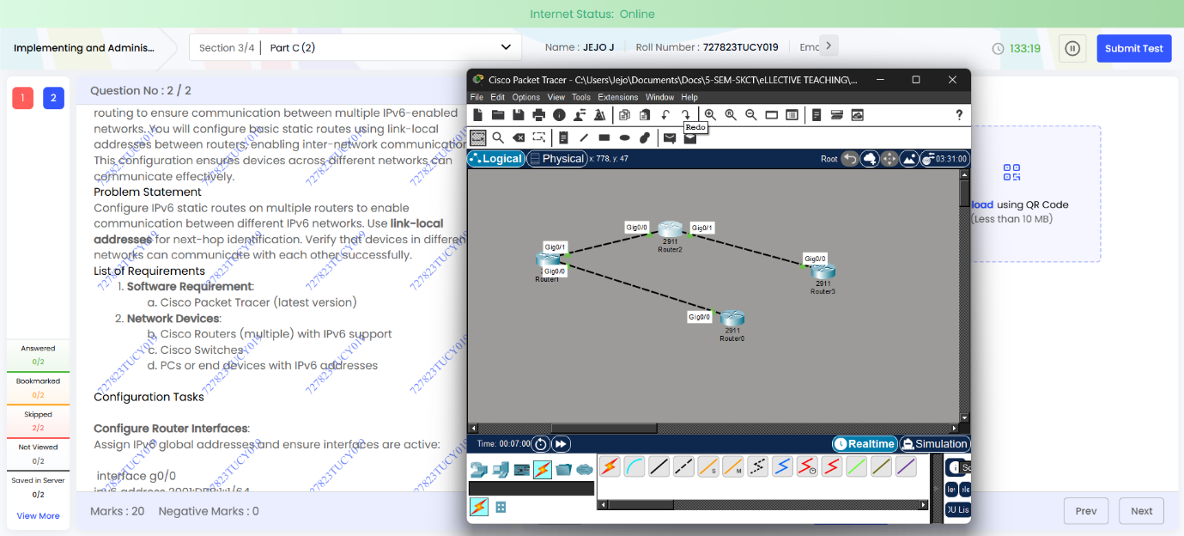
Router configuration:
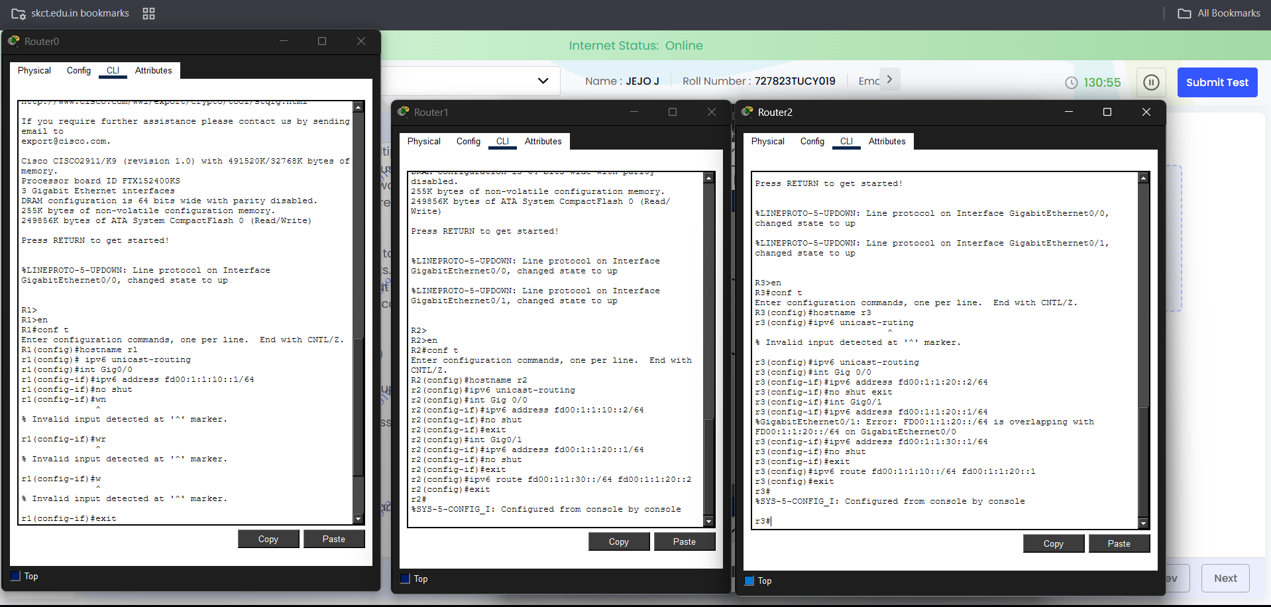

Ping request:

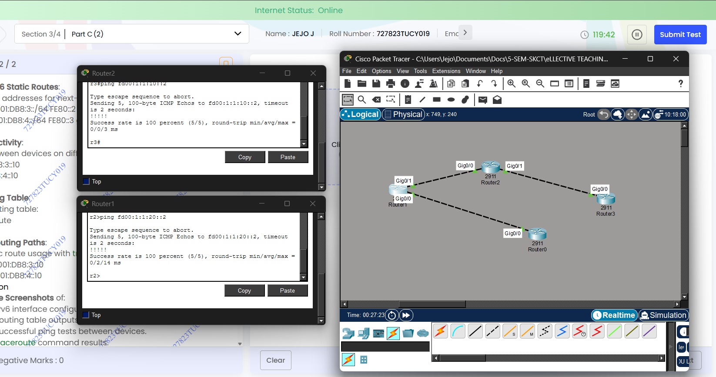

Name: Jejo J
Roll: 727823tucy019

